Feedback: Womens Wellbeing Day with GROW -Wellbeing, part of ‘Grow Together in the Callister Garden’
A women’s wellbeing day was run by the Callister Trust and GROW Wellbeing on Monday September 21st as part of ‘Grow Together in the Callister Garden’ a project working with refugees and asylum seekers alongside the garden’s local volunteers. This day offered a chance for women volunteers and women who are refugees/asylum seekers to attend. The activities were organised in separate spaces across the garden to allow for social distance because of Covid19 restrictions.
Activities included arts and crafts- tile design inspired by the natural surroundings, weaving, outdoor yoga and mindfulness and dancing led by one of the asylum seeker attendees. There was also an outdoor kitchen and campfire lunch.

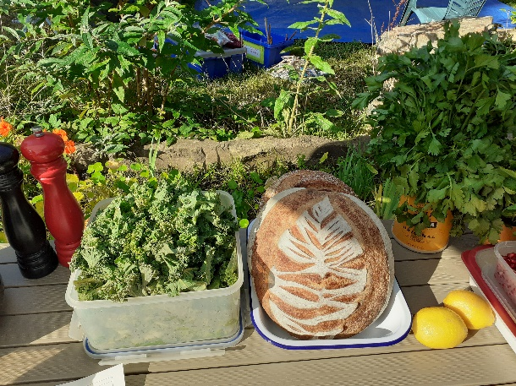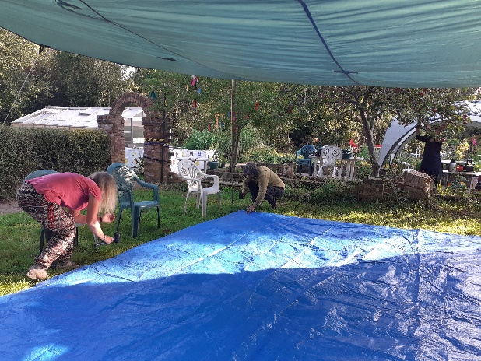

‘Lovely inclusive and relaxing atmosphere’ (Community attendee)
There were fourteen attendees including local refugees, asylum seekers, Callister volunteers
and trustees and women from the local community.
The day was led by 3 staff from GROW Wellbeing supported by 1 of the Callister trustees.
‘The facilitation of the day was fabulous. A range of activities to get involved in as well as structured sessions made the day flow beautifully.’ (Community attendee)
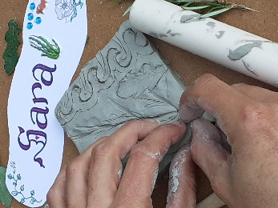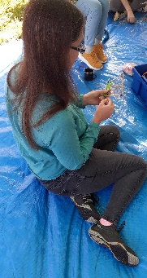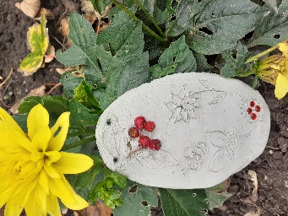
The creative activities were much appreciated. One attendee said of the tile design that if she had ever done anything like it before it was as a child and she had found it ‘great fun’.
The outdoor yoga was much appreciated and the dance led by one of the asylum seekers was a joyous celebration of community and friendship between women of different origins.

‘I liked the pottery paintings that we made so the women worked creatively’ (asylum seeker attendee)
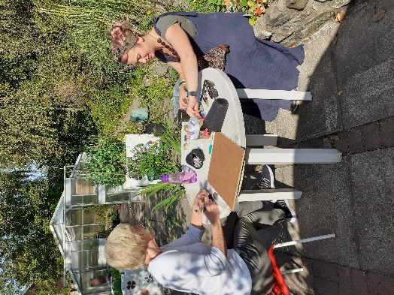
Beautiful reflections hung on labels around the garden summed up the feelings of the day and everyone said they would love to come again.

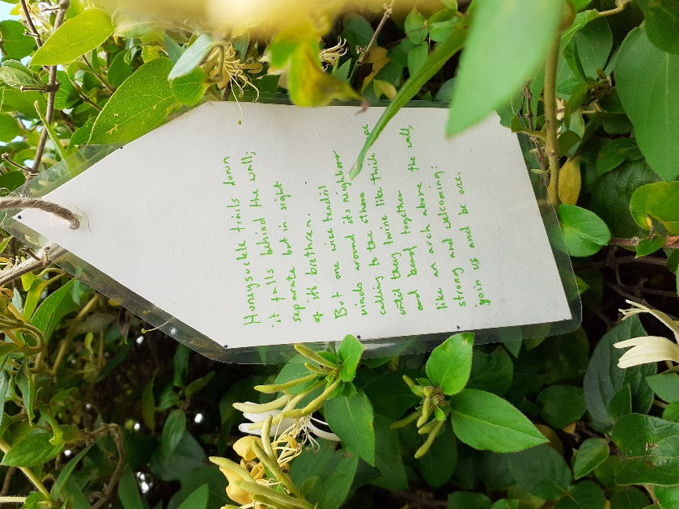
What I like the most was the presence of women with beautiful hearts and charming smiles. (asylum seeker attendee)

