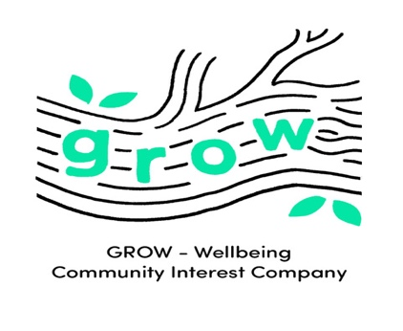 January 2019

Forest Sessions Information &
Standard Terms and Conditions
Activities
There will be a number of activities and experiences for children running through all GROW Forest sessions. A range of resources and games will be brought to each session, enabling children to use their imagination, to explore and follow their curiosity, engage in physical, and at times risky play, and manage the risks that they face.
Because of the nature of the woodland natural environment, and children and young people’s exposure to these challenges and risks, they may at times leave the session with scratches, bumps and bruises, which we trust you will recognise and anticipate as normal consequences of your child’s engagement with the natural environment. GROW will of course record all incidents warranting inclusion in the Accident Record Book.
Tool safety
GROW Forest leaders are experienced and trained in using tools. Some activities will include the safe use of tools. Tools used may include small bushcraft knives, secateurs, junior hacksaws and bowsaws, and include fire steels, which may be used during a session in a small group or on a one to one basis (whenever this is appropriate). Instruction and discussion will take place about holding and using tools and all children must first demonstrate their understanding of the safety elements, and how to be responsible, before they are given the opportunity to use tools. Keeping each individual and the whole of the group safe is paramount.
Access to tools is permitted only with the express permission of the GROW forest leader, and as such, participants should not take hold of any tool or fire lighting device without the permission of the GROW leader present. After use, children and adults should return any tools used to the container/ bag from which they were taken to ensure the safety of all participants.

Fire safety
There may be a campfire or activities based on fire lighting at GROW Forest sessions. Fires and fire lighting provide many therapeutic benefits to children, including enhancing a child’s self-esteem when they have successfully contributed to the making of a fire. Children must demonstrate their understanding of fire safety prior to the fire being lit. The safety of the whole group is paramount and the GROW Forest leader will assess the risk / benefit of having a fire during each session.
Photo-consent
In order to comply with GROW-Wellbeing’s Data Protection Policy, parents/carers are asked to provide written consent for the taking and recording of images, prior to any session beginning. Any images captured will be processed in line with best practice and in full compliance with the GRDP 2018.
During any GROW sessions, participants or parents/carers of participants are requested to restrict the taking of photographs to just the children in their care, unless they have the express permission of another parent or carer to photograph the children in their care, as this may otherwise contravene the GRDP 2018. Photographs of individual child and adult participants, taken by GROW, may be provided in digital format on request and by negotiation with the Programme Director.
Mobile phones
GROW would politely request that all participants and parents/carers of participants do not use their mobile phones, tablets or other devices during the GROW session, other than to take photo or video of their own children. You are requested therefore to put your phone away safely in a personal bag during the session, unless there is an anticipation of an emergency call being expected, if so, please advise the Forest School leader of this at the start of the session.
There are two key reasons for this request:
- In order to comply with the GROW Data Protection Policy, restricting use of photo and video recording.
- GROW-Wellbeing sessions are intended to provide enjoyment of the natural environment, removed from the usual distractions of urban life. Use of mobile phones, tablets and other devices may adversely impact on both your and other participants’ enjoyment of the natural environment.

Bookings & Cancellations
Bookings are non-refundable. If you are unable to attend, GROW will give you the option of an alternative date. Sessions will only be cancelled in the event of severe winds or an electrical storm. In the event of this, you will be given the option of an alternative date or a full refund.

